User Manual

Simple Calculator

Version 1.0

Prepared by:

Ashiwin

2 December 2014

Table of Contents

Section 1: About the Application 3

Section 2: Performing Calculations 7

# Section 1: About the Application

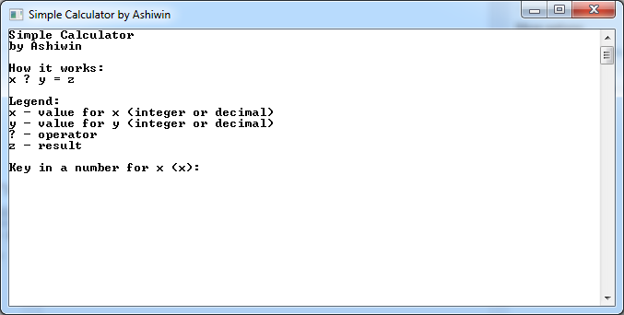

Figure 1 The calculator screen

When launching the Console Application, the user will be presented with instructions on how the calculator will function. The calculator processes basic mathematical functions according to this formula:

*x ? y = z*

where *x* and *y* are numbers in either round or decimal formats, *?* is one of the four basic operators: addition, subtraction, multiplication and division, and *z* which is the result of the equation.

The application will request the values of *x* and *y*. User will then key in the respective numbers. Validation is enforced so that the calculator will only accept numerical values.

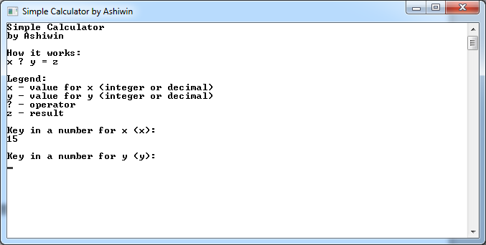

Figure 2 Numerical value entered. User can proceed with calculation

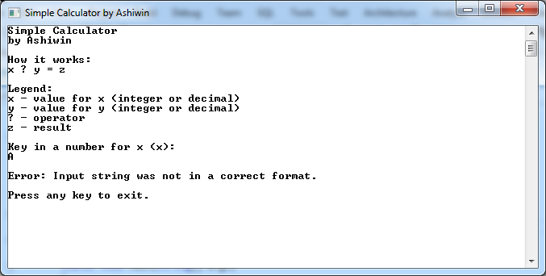

Figure 3 Alphabetical value entered. Error message is displayed

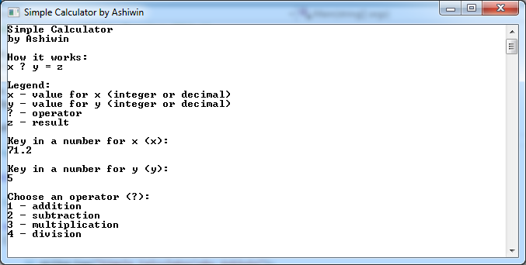

Figure 4 Operator functions

After keying in the values for *x* and *y*, the user will then be prompted to choose an operator. The user will have to key in the respective numbers to continue:

1. 1 for addition
2. 2 for subtraction
3. 3 for multiplication, and
4. 4 for division.

User will then be presented with the result of the equation.

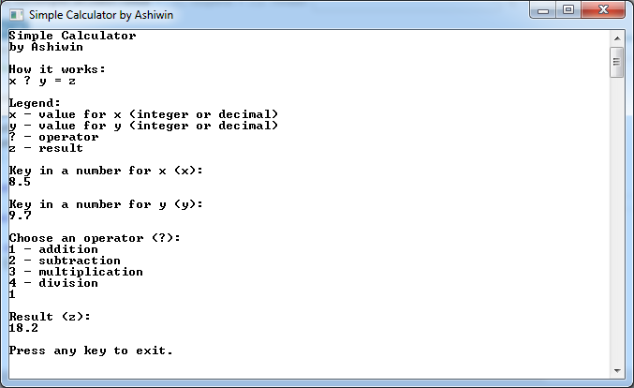

Figure 5 Example of a successful equation

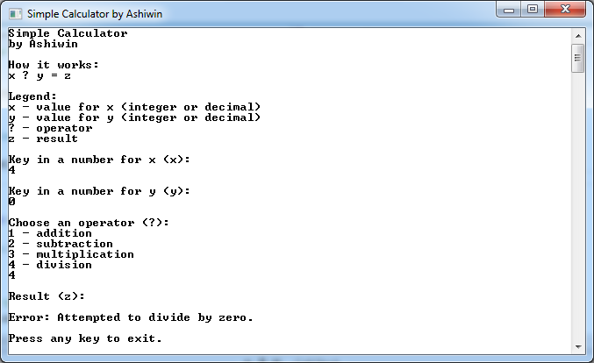

Figure 6 Example of an unsuccessful equation, i.e. division by zero

# Section 2: Performing Calculations

For example, if the user wants to make a calculation for the following equation:

21.5 + 32.6 = 54.1

They will have to do the following:

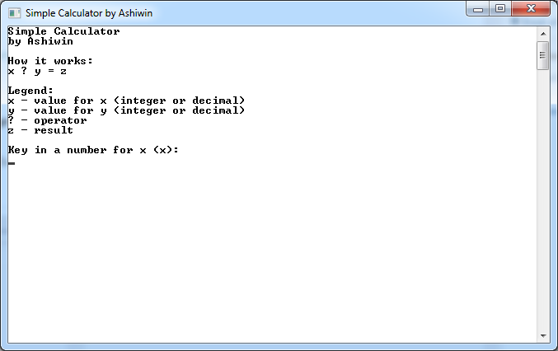  
Step 1: Launch the application

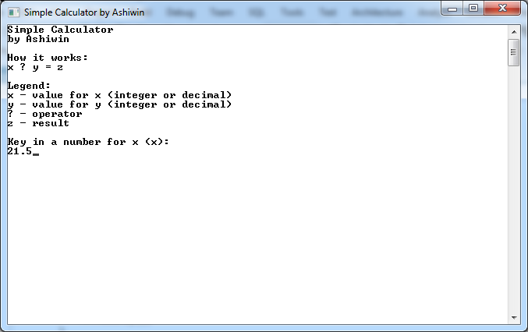  
Step 2: Type 21.5 and press Enter

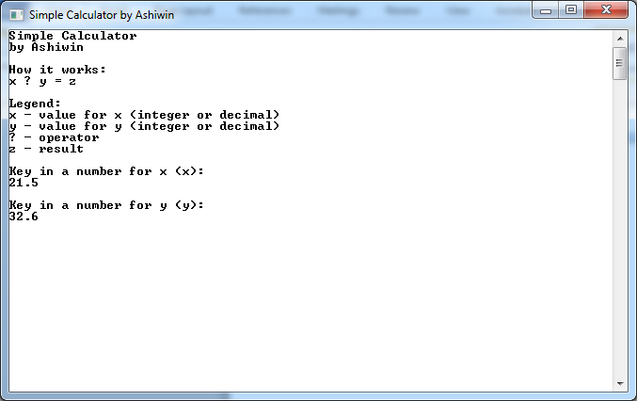  
Step 3: Type 32.6 and press Enter

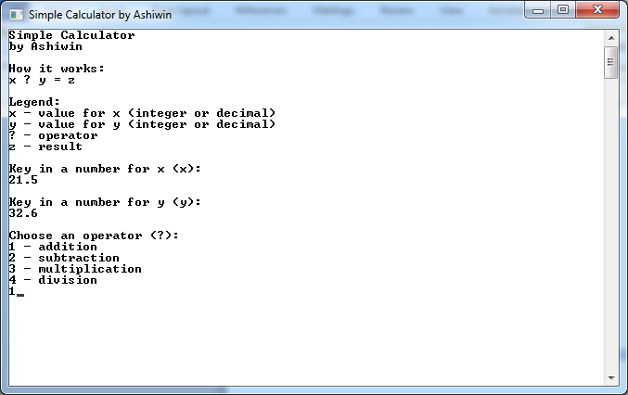  
Step 4: Press 1 for Addition and press Enter

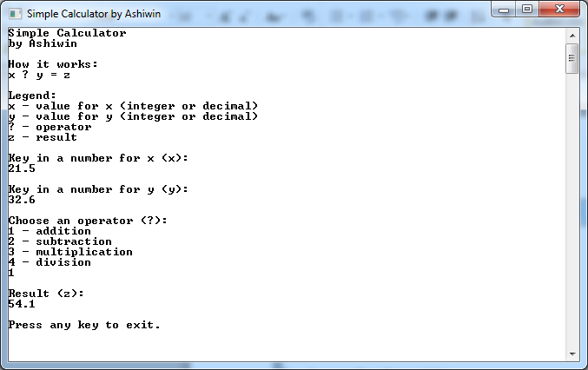  
Step 5: Result is displayed

End of Document